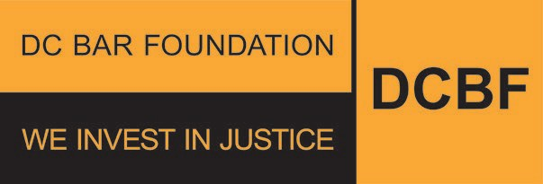
200 Massachusetts Ave., NW, 7th Floor P | 202-467-3750 Washington, DC 20001 www.dcbarfoundation.org F | 202-467-3753

DC Bar Foundation FY24 Grants Demographic Survey Questions
The following questions will be included in the Organizational Profile section of the FY24 grant applications.

Board Members and Staff
Number of board members:
Number of executive/management staff:
Number of supervising attorneys:
Number of line attorneys:
Number of non-attorney legal staff (e.g., legal assistants, legal associates, paralegals): Number of non-legal service staff (e.g., social workers, outreach workers, case managers):
Number of non-legal administrative staff (e.g., human resources, accountants or bookkeepers, receptionists):
Total number of board members:
Total number of staff:

Board Members and Staff by Gender
Number of board members:
Number of executive/management staff:
Number of supervising attorneys:
Number of line attorneys:
Number of non-attorney legal staff (e.g., legal assistants, legal associates, paralegals): Number of non-legal service staff (e.g., social workers, outreach workers, case managers):
Number of non-legal administrative staff (e.g., human resources, accountants or bookkeepers, receptionists):
Total number of board members Total number of staff

Board Members and Staff by Race

Number of board members:
Number of executive/management staff:
Number of supervising attorneys:
Number of line attorneys:
Number of non-attorney legal staff (e.g., legal assistants, legal associates, paralegals): Number of non-legal service staff (e.g., social workers, outreach workers, case managers):
Number of non-legal administrative staff (e.g., human resources, accountants or bookkeepers, receptionists):
Total number of board members:
Total number of staff:

Board Members and Staff by Ethnicity
Number of board members:
Number of executive/management staff:
Number of supervising attorneys:
Number of line attorneys:
Number of non-attorney legal staff (e.g., legal assistants, legal associates, paralegals): Number of non-legal service staff (e.g., social workers, outreach workers, case managers):
Number of non-legal administrative staff (e.g., human resources, accountants or bookkeepers, receptionists):
Total number of board members: Total number of staff:

