200 Massachusetts Ave, NW, Suite 700 P | 202-467-3750

Washington, DC 20001   www.dcbarfoundation.org F | 202-467-3753

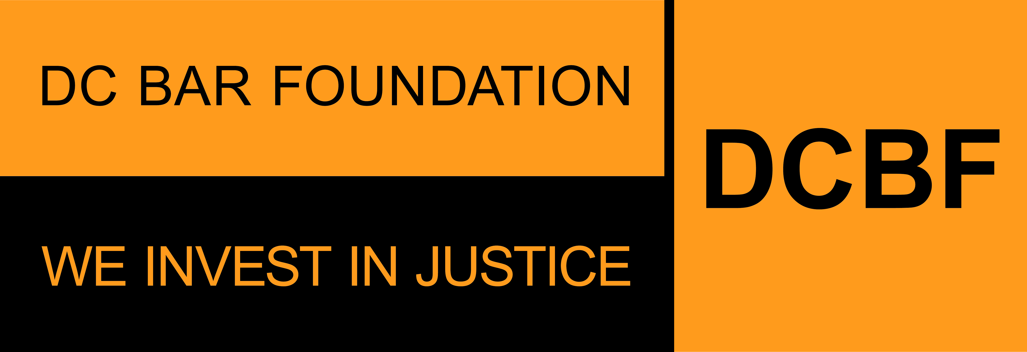

**FY2025 General Support Grants Program**

**General Operating Support**

**APPLICATION SAMPLE FORM**

**Applications due by 11:59pm ET on Friday, August 30, 2024**

Before beginning the application, please read the program guidelines, application instructions, and award process information: <https://www.dcbarfoundation.org/grants>. Sample application forms are available via the specific grant program under the link.  
  
For technical assistance, refer to: [https://dcbarfoundation.org/grantee-portal/.](https://dcbarfoundation.org/grantee-portal/) If you have questions about the application or application process, please email [grants@dcbarfoundation.org.](mailto:grants@dcbarfoundation.org)

**Applicant Information**

Organization Information: Name; Address

Applicant Information: Name; Phone; Email

**Executive Summary**

Please provide information for the most senior legal staff member working directly on the project: First Name; Last Name; Email; Job Title

Type of Support Requested: General Operating Support

**Budget Information**

Funding Request: *(For the period January 1 – December 31)*

**Application Narrative**

*(Please limit your responses to each question to 500 words or less.)*

**Need and Project or Services Description**

Describe the needs your legal services address. Use data to provide evidence of need.

Describe how your organization or project addresses these needs; provide a description of services provided.

**Impact of this Funding**

How does your organization conduct outreach to engage DC residents with low income or under-served who would benefit from your services? Please include how your organization engages with external institutions for outreach, if applicable.

What outcomes do you expect from the services you are providing? Instead of thinking about how many people received services, think about what will happen as a result of the service you are providing.

**Attachments** – the following documents will be uploaded with your application:

**Data Packet**

*General Support Grants Program applications requesting* ***General Operating Support should complete only tabs C, D & E of the Data Packet.***

Download the document via the DCBF website under this link: [https://www.dcbarfoundation.org/general-support-grants.](https://www.dcbarfoundation.org/general-support-grants)

Upload the completed document as an Excel file.

**Supporting Documentation**

Upload any supplemental materials as necessary in support of your grant proposal.

Upload as a PDF file.

**Signatures**

In the grants management system, click the Submit – Pending Signature button to submit the completed application for e-signature by the persons listed as Executive Director and Board Chair in your Organization Profile.

**Signature:**

Executive Director/President/CEO

Board Chair/President