200 Massachusetts Ave, NW, Suite 700 P | 202-467-3750

Washington, DC 20001   www.dcbarfoundation.org F | 202-467-3753

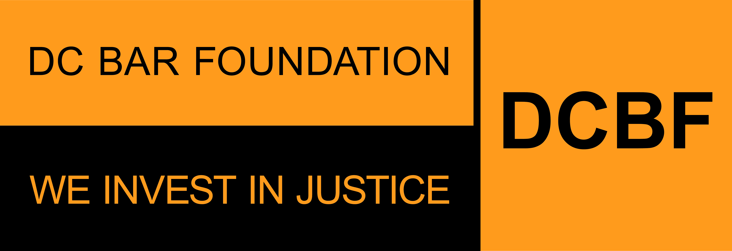

**FY2025 General Support Grants Program**

**Project Support Grant**

**APPLICATION SAMPLE FORM**

**Applications due by 11:59pm ET on Friday, August 30, 2024**

Before beginning the application, please read the program guidelines, application instructions, and award process information: <https://www.dcbarfoundation.org/grants>. Sample application forms are available via the specific grant program under the link.  
  
For technical assistance, refer to: [https://dcbarfoundation.org/grantee-portal/.](https://dcbarfoundation.org/grantee-portal/) If you have questions about the application or application process, please email [grants@dcbarfoundation.org.](mailto:grants@dcbarfoundation.org)

**Applicant Information**

Organization Information: Name; Address

Applicant Information: Name; Phone; Email

**Executive Summary**

Please provide information for the most senior legal staff member working directly on the project: First Name; Last Name; Email; Job Title

Type of Support Requested: Project Support Grant

Project Name:

Is this a new project? Y/N

In one or two sentences, provide a short description of this project.

**Budget Information**

Funding Request: *(For the period January 1 – December 31)*

Total Project Budget: *(For the period January 1 – December 31)*

Percent of Project Request to Be Funded by DCBF: *(auto-calculated)*

**Application Narrative**

*(Please limit your responses to each question to 500 words or less.)*

**Need and Project or Services Description**

Describe the needs your legal services address. Use data to provide evidence of need.

Describe how your organization or project addresses these needs; provide a description of services provided.

How does your organization engage pro bono attorneys and other volunteers to expand client services or otherwise assist the organization?

**Impact of this Funding**

Is this request to support direct legal services? Y/N If YES:

* Estimate the total number of DC residents who are low income or under-served who will benefit from this funding.

Indicate the specific geographical area and/or target community that will benefit from this funding.

*If the request is to support direct legal services, answer the following:*

How does the proposed project conduct outreach to engage DC residents who are low-income or under-served who would access these services? Please include how your organization/project team engages with external institutions for outreach, if applicable.

*If the request is NOT to support direct legal services, answer the following:*

How does the proposed project conduct outreach to engage the stakeholders who would benefit from the legal services this project connects with?

What outcomes do you expect from the services that would be funded under this grant? Instead of thinking about how many people received services, think about what will happen as a result of the service you are providing.

**Attachments** – the following documents will be uploaded with your application:

**Data Packet**

*General Support Grant Program applications requesting* ***Project Support should complete only tabs A & B of the Data Packet.***

Download the document via the DCBF website under this link: <https://www.dcbarfoundation.org/general-support-grants>

Upload the completed document as an Excel file.

**Budget Explanation Notes**

Download the document via the DCBF website under this link: <https://www.dcbarfoundation.org/general-support-grants>

Upload the completed document as a PDF file.

**Supporting Documentation**

Upload as a PDF file.

**Resumes**

Current resumes of all staff and supervisory personnel who will be involved in the activity for which funding is sought. If any positions are currently vacant, include the position’s job descriptions. Please upload each resume as a separate PDF file and include the project staff person's name in the file name. If you are uploading a position description include the position title in the file name.

**Signatures**

In the grants management system, click the Submit – Pending Signature button to submit the completed application for e-signature by the persons listed as Executive Director and Board Chair in your Organization Profile.

**Signature:**

Executive Director/President/CEO

Board Chair/President