200 Massachusetts Ave, NW, Suite 700 P | 202-467-3750

Washington, DC 20001   www.dcbarfoundation.org F | 202-467-3753

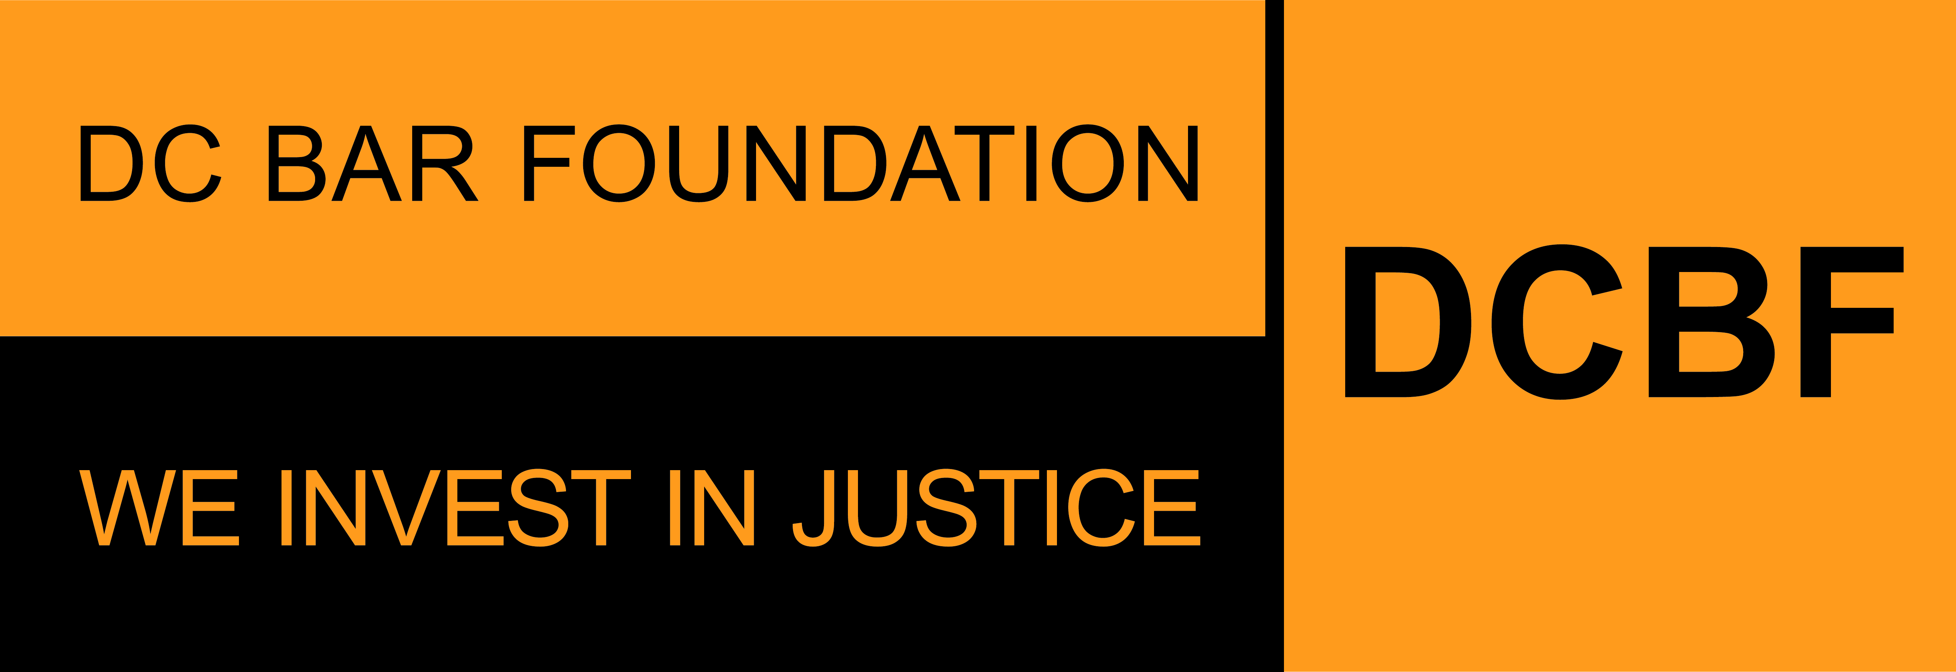

**FY2026 Grant APPLICATION SAMPLE FORM**

**Part 1: Non-Legal Service Provider Organization Profile**

**Applications due by 5:00pm ET on Friday, August 29, 2025**

Before beginning the application, please read the program guidelines, application instructions, and award process information: <https://www.dcbarfoundation.org/grants>. Sample application forms are available via the specific grant program under the link.  
  
For technical assistance, refer to: [https://dcbarfoundation.org/grantee-portal/.](https://dcbarfoundation.org/grantee-portal/) If you have questions about the application or application process, please email [grants@dcbarfoundation.org.](mailto:grants@dcbarfoundation.org)

The **ORGANIZATION PROFILE** information describes your organization. This is a description of your organization – not a description of your project/proposal.  
  
**Your Organization Profile information is entered in the Grants Management System one time.** If you are applying for more than one grant, this information will be automatically included in all applications for the Access to Justice, Civil Legal Counsel Projects Program (CLCPP), and General Support grant programs.

**Organization**

Organization Name:

EIN Number:

Street Address: Street Address 2:

City: State: Zip Code:

Website URL:

**Organization Category:**

Legal Service Provider / Non-Legal Service Provider

*The information you complete on your Organization Profile and grant application(s) will be determined by your organization category: Legal Service Provider Organization or Non-Legal Servics Provider Organization. Your organization category is displayed below. If the organization category is NOT correct, please notify us at grants@dcbarfoundation.org and request that your category information be updated.*

**Physical Address Where Services Are Being Provided**

Is your physical address different from above?

**SAM.gov Registration Verification**

Is your organization's/entity's SAM Registration Status ACTIVE?

*In order to receive funds from DCBF, your organization/entity must maintain active registration with the federal System for Award Management (SAM). If you answer that your organization/entity has an active registration, you will be prompted to provide your Unique Entity ID. You are not required to have an active SAM registration in order to submit an application for funding; however, if your project is selected for funding, grant funds cannot be disbursed until DCBF has been able to confirm an active SAM registration. If you have any questions, please contact grants@dcbarfoundation.org.*

Enter your SAM Unique Entity ID. If your registration is INACTIVE or you have not received your ID, please leave the default value of zero:

**Organization's Budget Information**

Fiscal Year Start Date:

Fiscal Year End Date:

Total Organizational Budget:

**Mission**

What is your organization's mission statement?

What is your organization's experience in providing services to DC residents with low incomes or who are underserved?

What DC communities does your organization serve?

What do you see as the civil legal needs of the people you serve?

**Organization's Systems for Promoting Quality, Efficiency, and Effectiveness in the Delivery of Services**

In the last year, how did your organization use client feedback to improve its services?

Please describe your organization’s data collection, tracking, and evaluation methodologies including data collected at intake, timeframes, type of data collected, frequency of data collection, staffing, and technology related to these efforts.

The DC Bar Foundation is committed to infusing racial justice and equity in our work, and we are committed to evolving our practice and culture to learn, reflect, unlearn and change our practices in the pursuit of justice. Please use the space below to describe how your organization integrates racial equity into your organizational culture as well as the legal services associated with this proposal.

Explain any capacity building needs that would help you reach your organizational and programmatic goals during the grant year.

Is your organization currently participating in the DC Resource Bridge, or planning to join as a participant organization that receives referrals? If yes, please briefly describe the extent of your current participation or future plans.

**Executive/Board Information**

Executive Director Information

Prefix:

First Name: Last Name: Job Title: Email:

Office Phone Number: Extension:

Board Chair Information

*If you are awarded a grant, you will receive your grant agreement via DocuSign. To streamline the grant agreement process, please provide the name and email address of the Board Chair as of January 1 of the upcoming year-- that is, the first day of the term for all new grant agreements.*

First Name: Last Name: Email:

**Demographic Survey**

Board Members and Staff

Number of board members:

Number of executive/management staff:

Number of supervising staff:

Number of line staff:

Number of administrative staff:

**REQUIRED FILE UPLOADS (ATTACHMENTS)**

**Nonprofit Status** – upload as a PDF

*The organization's Internal Revenue Service ruling letter regarding applicant's tax-exempt status.*

**Organizational Budget** – upload as a PDF

*The organization's current annual budget, including breakout of expenditures specifically for services to DC residents with low incomes.*

**Form 990** – upload as a PDF

*Provide the organization’s most recent Form 990.*

**Audited Financial Statements** – Upload tas a PDF

*Provide the organization’s most recent audited financial statements, including the auditor’s notes and management letter.*

**Client Eligibility Guidelines on Residency and Income**

*Download the document via the DCBF website.*

Upload the completed document as a PDF file.

**Explanation or Notes on the Financial Uploads (OPTIONAL)**

Upload the document(s) as a PDF file.