200 Massachusetts Ave, NW, Suite 700 P | 202-467-3750

Washington, DC 20001   www.dcbarfoundation.org F | 202-467-3753

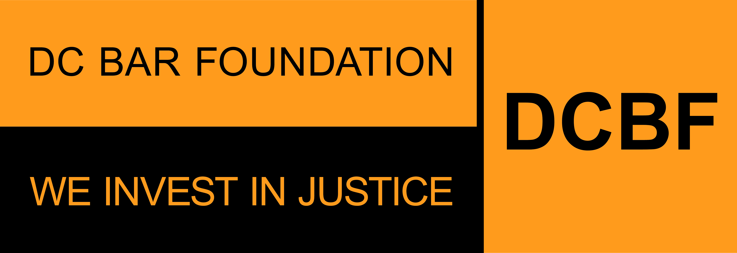

**FY2026 Grant APPLICATION SAMPLE FORM**

**Part 1: Legal Service Provider Organization Profile**

**Applications due by 5:00pm ET on Friday, August 29, 2025**

Before beginning the application, please read the program guidelines, application instructions, and award process information: <https://www.dcbarfoundation.org/grants>. Sample application forms are available via the specific grant program under the link.  
  
For technical assistance, refer to: [https://dcbarfoundation.org/grantee-portal/.](https://dcbarfoundation.org/grantee-portal/) If you have questions about the application or application process, please email [grants@dcbarfoundation.org.](mailto:grants@dcbarfoundation.org)

The **ORGANIZATION PROFILE** information describes your organization. This is a description of your organization – not a description of your project/proposal.  
  
**Your Organization Profile information is entered in the Grants Management System one time.** If you are applying for more than one grant, this information will be automatically included in all applications for the Access to Justice, Civil Legal Counsel Projects Program (CLCPP), and General Support grant programs.

**Organization**

Organization Name:

EIN Number:

Street Address: Street Address 2:

City: State: Zip Code:

Website URL:

**Organization Category:**

Legal Services Provider / Non-Legal Services Provider

*The information you complete on your Organization Profile and grant application(s) will be determined by your organization category: Legal Service Provider Organization or Non-Legal Service Provider Organization. Your organization category is displayed below. If the organization category is NOT correct, please notify us at grants@dcbarfoundation.org and request that your category information be updated.*

**Physical Address Where Services Are Being Provided**

Is your physical address different from above?

**SAM.gov Registration Verification**

Is your organization's/entity's SAM Registration Status ACTIVE?

*In order to receive funds from DCBF, your organization/entity must maintain active registration with the federal System for Award Management (SAM). If you answer that your organization/entity has an active registration, you will be prompted to provide your Unique Entity ID. You are not required to have an active SAM registration in order to submit an application for funding; however, if your project is selected for funding, grant funds cannot be disbursed until DCBF has been able to confirm an active SAM registration. If you have any questions, please contact grants@dcbarfoundation.org.*

Enter your SAM Unique Entity ID. If your registration is INACTIVE or you have not received your ID, please leave the default value of zero:

**Organization's Budget Information**

Fiscal Start Date:

Fiscal End Date:

Total Organizational Budget:

Current Legal Services Department Budget and Staffing:

Total Budget for Legal Services Department:

Number of Casehandling Non-Attorney Staff:

Number of Casehandling Legal Supervisors, Legal Directors and Executive Director:

Number of Casehandling Attorneys:

Number of Casehandling Senior Attorneys (not counted in any category above):

**Mission / Legal Services**

What is your organization's mission statement?

What is your organization's experience in providing free legal services to DC residents with low incomes or who are underserved?

What DC communities does your organization serve?

Are there any emerging civil legal needs of which DCBF should be made aware? Please describe. If there are none, enter NA

What, if any, major organizational changes have occurred recently that could significantly affect your organization's capacity to provide its planned legal services? How will you address the challenges or opportunities presented? If there are none, enter NA.

**Organization's Systems for Promoting Quality, Efficiency, and Effectiveness in the Delivery of Civil Legal Aid**

In the last year, how did your organization use client feedback to improve its legal services?

What systems or processes are in place for staff supervision and training, review of client needs, and outcomes tracking to ensure legal services are of high quality, and address needs?

In the last year, how did your organization collaborate with and influence stakeholders (including nonlegal stakeholders) involved with its client population? Please give one or two examples of your most significant recent collaborations.

Please describe your organization’s data collection, tracking, and evaluation methodologies including data collected at intake, timeframes, type of data collected, frequency of data collection, staffing, and technology related to these efforts.

The DC Bar Foundation is committed to infusing racial justice and equity in our work, and we are committed to evolving our practice and culture to learn, reflect, unlearn and change our practices in the pursuit of justice. Please use the space below to describe how your organization integrates racial equity into your organizational culture as well as the legal services associated with this proposal.

Explain any capacity building needs that would help you reach your organizational and programmatic goals during the grant year.

Given proposed cuts to the Access to Justice Initiative, what contingency planning is your organization undertaking if these cuts are realized? What are your organization's long-term strategies for sustaining your programs?

Does your organization have a pro bono coordinator?

How many pro bono coordinators does your organization have?

Is/Are the pro bono coordinator(s) assigned to particular program areas? (Yes / No). Please provide an explanation.

Is your organization currently participating in the DC Resource Bridge, or planning to join as a participant organization that receives referrals? If yes, please briefly describe the extent of your current participation or future plans.

**Executive/Board Information**

Executive Director Information

Prefix:

First Name: Last Name: Job Title: Email:

Office Phone Number: Extension:

Board Chair Information

*If you are awarded a grant, you will receive your grant agreement via DocuSign. To streamline the grant agreement process, please provide the name and email address of the Board Chair as of January 1 of the upcoming year-- that is, the first day of the term for all new grant agreements.*

First Name: Last Name: Email:

**Demographic Survey**

Board Members and Staff

Number of board members:

Number of executive/management staff:

Number of supervising attorneys:

Number of line attorneys:

Number of non-attorney legal staff (e.g., legal assistants, legal associates, paralegals):

Number of non-legal service staff (e.g., social workers, case managers):

Number of non-legal administrative staff (e.g., human resources, accountants or bookkeepers, receptionists):

**Demographic Survey Tables**

*You will enter details via an online form in the grants management system.*

*Count each board/staff member only once. Enter a number in each cell, even if the number is 0.  
  
The TOTAL column will automatically sum the values entered. Please ensure that the TOTAL displayed in the final column matches the number you entered for Number of Board Members, Number of executive/management staff, Number of supervising staff, etc. in the Total Board Members and Staff section.  
  
Use the scroll bars to scroll up/down and left/right to view all rows/columns in the table. Click the SAVE button to save your work. You can return to this form to add/edit information as long as the Organization Profile status is DRAFT.*

**Board Members and Staff by Gender**

|  |  |  |  |  |  |
| --- | --- | --- | --- | --- | --- |
| **Category** | **Female** | **Male** | **Transgender** | **Other / Non-binary** | **Unknown** |
| Board Members |  |  |  |  |  |
| Executive/Management |  |  |  |  |  |
| Supervising Staff |  |  |  |  |  |
| Line Staff |  |  |  |  |  |
| Administrative Staff |  |  |  |  |  |
| Totals by Category |  |  |  |  |  |

**Board Members and Staff by Race**

|  |  |  |  |  |  |
| --- | --- | --- | --- | --- | --- |
| **Category** | **White** | **Black or African American** | **American Indian or Alaska Native** | **Asian American** | **Hispanic or Latinx** |
| Board Members |  |  |  |  |  |
| Executive/Management |  |  |  |  |  |
| Supervising Staff |  |  |  |  |  |
| Line Staff |  |  |  |  |  |
| Administrative Staff |  |  |  |  |  |
| Totals by Category |  |  |  |  |  |

**Board Members and Staff by Ethnicity**

|  |  |  |  |
| --- | --- | --- | --- |
| **Category** | **Yes, Hispanic / Latinx** | **Not Hispanic or Latinx** | **Unknown** |
| Board Members |  |  |  |
| Executive/Management |  |  |  |
| Supervising Staff |  |  |  |
| Line Staff |  |  |  |
| Administrative Staff |  |  |  |
| Totals by Category |  |  |  |

**REQUIRED FILE UPLOADS (ATTACHMENTS)**

**Nonprofit Status** – upload as a PDF

The organization's Internal Revenue Service ruling letter regarding applicant's tax-exempt status

**Organizational Budget** – upload as a PDF

The organization's current annual budget, including breakout of expenditures specifically for civil legal services to DC residents with low incomes.

**Form 990** – upload as a PDF

Provide the organization’s most recent Form 990.

**Audited Financial Statements** – Upload the document(s) as a PDF file

Provide the organization’s most recent audited financial statements, including the auditor’s notes and management letter.

**Client Eligibility Guidelines on Residency and Income**

Download the document via the DCBF website

Upload the completed document as a PDF file.

**Explanation or Notes on the Financial Uploads (OPTIONAL)**

Upload the document(s) as a PDF file