1 of 4: Campaign Introduction Email (Sent by Team Leader to Colleagues)
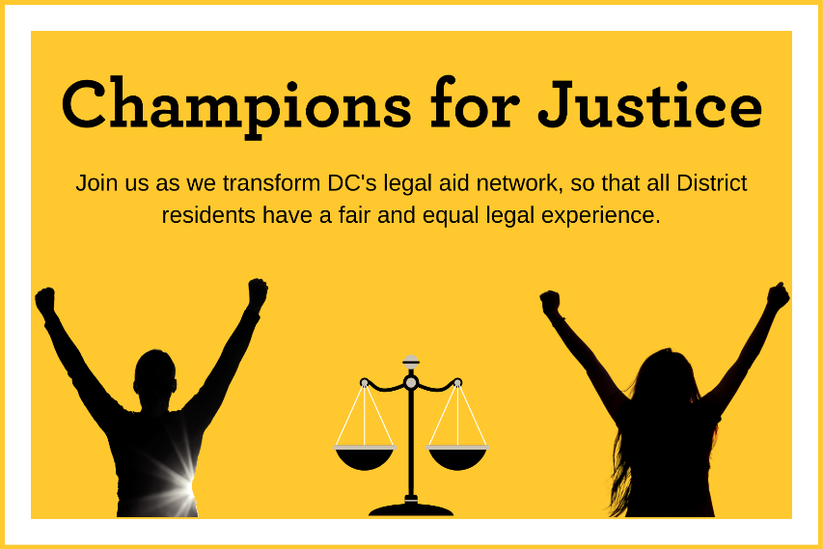
Champions for Justice is here! It's time to support the DC Bar Foundation (DCBF) – the leading funder of civil legal aid in DC, which distributed over $20 million to 36 DC legal aid organizations in 2022 alone.

In partnering with law firms across the city through Champions for Justice, the Foundation hopes to raise $42,000. Let's help them get there by raising [INSERT GOAL AMOUNT] by [GOAL DATE] as a firm!

The Foundation's grantees address the full range of civil legal needs for people who are underserved in our city: domestic violence, landlord/tenant, civil rights, disability benefits, special education – if there's an injustice in DC, they're fighting it. DCBF also supports its grantees through offering training and technical assistance and empowers legal services lawyers with overwhelming student debt by offering a private loan repayment assistance program (LRAP).
And while this direct financial support is vital, the Foundation is much more than a grants distributor. In addition to supporting network-building efforts like the Landlord-Tenant Legal Assistance Network, the Family Law Learning Network, and the newly emerging Racial Equity Learning Network, DCBF is currently working to build the first-ever District-wide Coordinated Intake and Referral system for all areas of civil legal aid.

It's no small feat, and our support helps make projects like this possible.

The Foundation will host a giveaway for all Champions for Justice participants each month. Check out how each month's giveaway will work below!
October: Send DCBF a picture of you in your favorite Halloween costume or outfit to be entered into their end-of-the-month giveaway. Two lucky winners will each receive a $50 Uber Eats gift card. Donations to DCBF are highly encouraged!
November: Tell DCBF what you're thankful for! All respondents to their "I'm thankful for..." prompt will be entered into their end-of-the-month giveaway. Two lucky winners will each receive a $50 Uber Eats gift card. Donations to DCBF are highly encouraged!
December: Tell DCBF about something you're looking forward to in the new year. All respondents to their "In 2022, I hope…" prompt will be entered into their end-of-month giveaway. Two lucky winners will each receive a $50 Uber Eats gift card. Donations to DCBF are highly encouraged!
The Foundation's extensive knowledge of DC's legal aid network means our dollars get put to the best use every time. And while DCBF receives funding from the District, those dollars come with restrictions for our grantees. In addition to supporting LRAP, private fundraising efforts like Champions for Justice support operating grants, meaning recipients can use the funds for critical things – e.g., keeping the lights on or replacing broken or outdated equipment – that other funding sources cannot cover.

I encourage you to join me in supporting [WORKPLACE NAME] 's Champions for Justice campaign by donating here: [INSERT LINK TO FIRM GIVING PAGE]. Help us reach our goal of [$GOAL] by [CAMPAIGN END DATE].

Thank you for your support, and get ready to be a Champion for Justice!

2 of 4: October Giveaway Email (Sent by Team Leader to Colleagues)
[FIRM NAME] 's Champions for Justice campaign, supporting the DC Bar Foundation, is underway. This year, we aim to raise [$GOAL]. Have you made your donation yet? Your dollars provide support to individuals in DC experiencing life-altering civil legal issues, like this client below:

[INSERT CLIENT STORY HERE]

As you can see, the Foundation is a vital resource for those in need in our city. And your gift makes a tangible difference.

As the campaign kicks off, the Champions for Justice October Challenge is underway! Want to have some festive fun and enter the DC Bar Foundation's end-of-the-month campaign giveaway?

Send a picture of you working in your favorite Halloween costume or outfit to Greer Richey, Development and Communications Specialist at the DC Bar Foundation, at richey@dcbarfoundation.org to be entered for a chance to win one of TWO $50 Uber Eats gift cards. Donations to DCBF, in addition to your photo, are highly encouraged to help us reach our [$GOAL] goal. Everyone who sends in a spooky photo, or makes a gift to DCBF, will be entered to win.

Make your gift here: [INSERT LINK TO FIRM'S CAMPAIGN PAGE]

Thank you for being a Champion for Justice for those in need in the District.

3 of 4: November Giveaway Email (Sent by Team Leader to Colleagues)

[FIRM NAME] 's Champions for Justice campaign, supporting the DC Bar Foundation, is underway. This year, we aim to raise [$GOAL]. We have [$AMOUNT] left to go. Will you donate and help us get there? Every dollar you give helps the DC Bar Foundation support people in DC experiencing life-altering civil legal issues, like this client below:

[INSERT CLIENT STORY HERE]

As you can see, the Foundation's funding, made possible in large part by support from generous donors, is vital. And your gift through this year's Champions for Justice campaign has an impact.

As the campaign continues, the Champions for Justice November Challenge is underway. Interested in entering the DC Bar Foundation's end-of-the-month campaign giveaway?

Answer DCBF's "I'm thankful for…" prompt to be entered for a chance to win one of TWO $50 Uber Eats gift cards. Donations to DCBF, in addition to your submission, are highly encouraged to help us reach our [$GOAL] goal. Everyone who answers the prompt, or makes a gift to DCBF, will be entered to win.

Make your gift here: [INSERT LINK TO FIRM'S CAMPAIGN PAGE]

Thank you for being a Champion for Justice for those in need in the District.

4 of 4: December Giveaway Email (Sent by Team Leader to Colleagues)

[FIRM NAME] 's Champions for Justice campaign, supporting the DC Bar Foundation, is coming to a close! This year, we aim to raise [$GOAL]. We're almost there, with just [$AMOUNT] left to go. Don't miss your chance to donate and support our campaign. Every gift towards our goal helps the DC Bar Foundation empower people in DC experiencing life-altering civil legal issues, like this client below:

[INSERT CLIENT STORY HERE]

The Foundation is a key player in the well-being of our city's civil legal aid ecosystem, supporting those who need it most. And your gift through this year's Champions for Justice campaign has an impact.

As the campaign continues, the Champions for Justice December Challenge is underway. Interested in entering the DC Bar Foundation's end-of-the-month campaign giveaway?

Tell DCBF what you're looking forward to in 2023 to be entered for a chance to win one of TWO $50 Uber Eats gift cards. Donations to DCBF, in addition to your submission, are highly encouraged to help us reach our [$GOAL] goal. Everyone who answers the prompt, or makes a gift to DCBF, will be entered to win.

Make your gift here: [INSERT LINK TO FIRM'S CAMPAIGN PAGE]

Thank you for supporting our campaign and being a Champion for Justice for those in need in the District.

